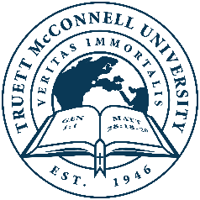
Truett McConnell University
Master of Arts in Global Mental Health Counseling with Sports Psychology
Degree Program Checklist
Student: __________________________ID#:_____________Advisor:______________________

Class Hours Grade Semester

Required Courses
CS 500 Word and Witness in the Workplace 3 _______ _______
CL 526 Counseling Children & Adolescents 3 _______ _______
CL 540 Marriage & Family Counseling 3 _______ _______
CL 551 Multicultural Theories: Counseling
Across Cultures 3 _______ _______
CL 560 Theories and Techniques of Counseling 3 _______ _______
CL 590 Advanced Psychopathology & Diagnosis OR
CL 520 Advanced Human Growth and Development 3 _______ _______
CL 601 Biblical Counseling OR
CL 640 Transformational Psychology 3 _______ _______
CL 651 Trauma OR
CL 660 Addiction 3 _______ _______
CL 680 Professional Orientation and Ethics 3 _______ _______
CL 600 The Psychology of Sport 3 _______ _______
CL 697 Applied Practicum and Treatment Planning 3 _______ _______

Elective Courses (Choose 1 from the following)
CS 635 World Religions & Apologetics 3 _______ _______
MI 501 Evangelism, Discipleship, & Church Planting 3 _______ _______
MI 620 Cultural Analysis & Ministry 3 _______ _______
OR any CL course offered by the school that is not listed above

6 hours documented, personal counseling _______ _______

Total Hours 36

TMU 2025-2026 Degree Program Checklist: Master of Arts Global Mental Health Counseling Page 1-1

