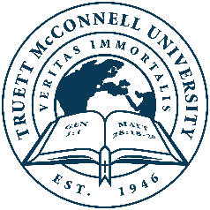

**Truett McConnell University**

**Master of Arts in Global Mental Health Counseling**

**Degree Program Checklist**

Student: __________________________ID#:_____________Advisor:______________________

**Class** **Hours**  **Grade** **Semester**

**Required Courses**

CS 500 Word and Witness in the Workplace 3 _______ _______

CL 525 Counseling Children & Adolescents 3 _______ _______

CL 540 Marriage & Family Counseling 3 _______ _______

CL 550 Multicultural Theories: Counseling

Across Cultures 3 _______ _______

CL 560 Theories and Techniques of Counseling 3 _______ _______

CL 590 Advanced Psychopathology & Diagnosis OR

CL 520 Advanced Human Growth and Development 3 _______ _______

CL 601 Biblical Counseling OR

CL 640 Transformational Psychology 3 _______ _______

CL 650 Trauma OR

CL 660 Addiction 3 _______ _______

CL 680 Professional Orientation and Ethics 3 _______ _______

CL 697 Applied Practicum and Treatment Planning 3 _______ _______

**Elective Courses (Choose 2 from the following)**

CL 600 The Psychology of Sport 3 _______ _______

CS 635 World Religions & Apologetics 3 _______ _______

MI 501 Evangelism, Discipleship, & Church Planting 3 _______ _______

MI 620 Cultural Analysis & Ministry 3 _______ _______

OR any CL course offered by the school that is not listed above

**6 hours documented, personal counseling** _______ _______

**Total Hours 36**

**TMU 2025-2026 Degree Program Checklist: Master of Arts Global Mental Health Counseling Page 1-1**